## **What is Prometheus?**

Prometheus is a free software application used for event monitoring and alerting. Prometheus is an open-source systems monitoring and alerting toolkit.It records real-time metrics in a [time series database](https://en.wikipedia.org/wiki/Time_series_database) built using a HTTP model with flexible queries and real-time alerting.

* Prometheus was developed at SoundCloud starting in 2012.
* Prometheus was introduced for production monitoring at SoundCloud By 2013.
* In May 2016, the Cloud Native Computing Foundation accepted Prometheus as its second incubated project, after Kubernetes.
* Prometheus 1.0 was released in July 2016
* Prometheus 2.0 in November 2017]
* The project is written in Go and licensed under the Apache 2 Licence
* Source code available on GitHub
* A multi-dimensional data model
* Operational simplicity
* Scalable data collection
* Powerful query language

## **Features of Prometheus**

Prometheus’s main features are:

* A multi-dimensional data model with time series data identified by metric name and key/value pairs
* PromQL, a flexible query language to leverage this dimensionality
* No reliance on distributed storage; single server nodes are autonomous
* Time series collection happens via a pull model over HTTP
* Pushing time series is supported via an intermediary gateway
* Targets are discovered via service discovery or static configuration
* Multiple modes of graphing and dashboarding support

## **What are the Prometheus Components?**

A typical monitoring platform with Prometheus is composed of multiple tools:

* **Prometheus server:** the main Prometheus server which scrapes and stores time series data
* **Client libraries:** client libraries for instrumenting application code
* **Push gateway:** a push gateway for supporting short-lived jobs
* **Exporters:** special-purpose exporters for services like HAProxy, StatsD, Graphite, etc.
* **Alertmanager:** an alertmanager to handle alerts

## **What is Grafana?**

Grafana is an open source web application, which is used to analyse and visualise the data with help of charts and graphs. Grafana is developed by Grafana Labs. It helps the user to see their data via charts and graphs on tha grafana dashboard.

Grafana is very useful for team work, users can share its dashboard with other team members and other team members can also collaborate their work and data.

**Features of Grafana**

* **Panels:** users can visualise any data using histograms, graphs, geomaps, heatmaps, etc.
* **Plugins:** Transfer data in real time on a user-friendly API via panel plugins that hook into existing data sources—no data migration required. users can also create data source plugins, retrieving metrics from any custom API.
* **Alerts:** One user can create, consolidate, and control all its alerts.
* **Transformations:** Rename, summarise, combine, and perform calculations across data sources and queries.
* **Annotations:** Use rich events from different data sources to annotate graphs.
* **Panel Editor:** A consistent user interface for configuring and customising the panels.

**Grafana default port no. - 3000**

**Setup Prometheus:-**

I follow some steps for setup prometheus in ubuntu which is given below:-

**Step 1:-** create a system user or system account-

$ sudo useradd \

--system \

--no-create-home \

--shell /bin/false prometheus

**Step 2:-** download the Prometheus

$ sudo wget <https://github.com/prometheus/prometheus/releases/download/v2.40.1/prometheus-2.40.1.linux-amd64.tar.gz>

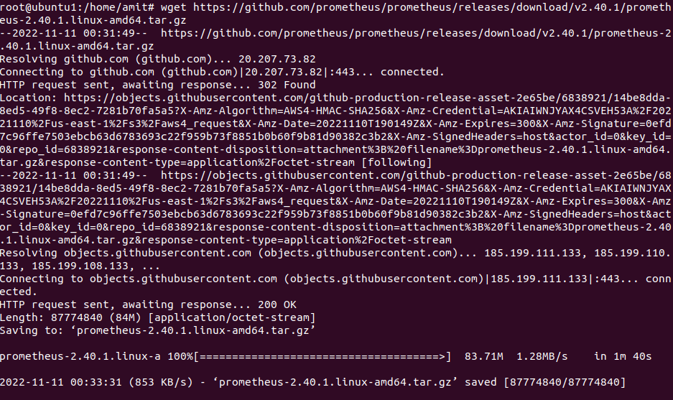

**Step 3 :-** extract Prometheus files from the archive.

$ sudo tar -xvf prometheus-2.40.1.linux-amd64.tar.gz

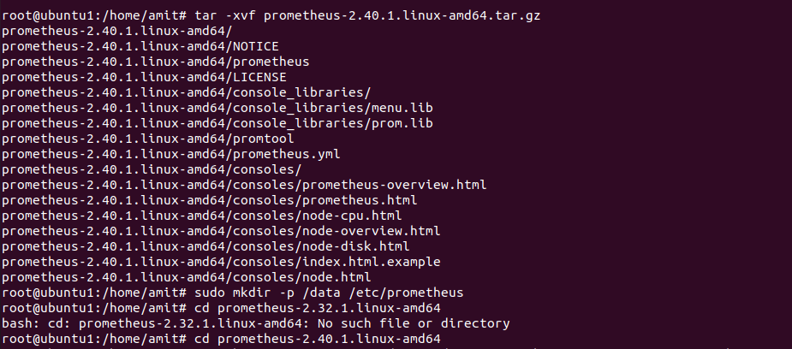

**Step 4:-** create a /**data** director and a directory(Prometheus) for Prometheus configuration files.

$ sudo mkdir -p /data /etc/prometheus

**Step 5:-** go to **Prometheus-2.40.1.linux-amd64** directory

$ sudo cd Prometheus-2.40.1.linux-amd64

**Step 6:-** move the prometheus binary and a promtool to the /usr/local/bin/

$ sudo mv prometheus promtool /usr/local/bin/

**Step 7:-** move console libraries to the Prometheus configuration directory.

$ sudo mv consoles/ console_libraries/ /etc/prometheus/

**Step 8:-** move the main prometheus configuration file.

$ sudo mv prometheus.yml /etc/prometheus/prometheus.yml

**Step 9:-** set correct ownership for the /etc/prometheus/ and data directory.

$ sudo chown -R prometheus:prometheus /etc/prometheus/ /data/

**Step 10:-** delete the archive and a Prometheus folder when you are done.

$ cd ..

$ rm -rf prometheus*

**Step 11:-** create a systemd unit configuration file.

$ sudo vim /etc/systemd/system/prometheus.service

Then, paste it in the file

[Unit]

Description=Prometheus

Wants=network-online.target

After=network-online.target

StartLimitIntervalSec=500

StartLimitBurst=5

[Service]

User=prometheus

Group=prometheus

Type=simple

Restart=on-failure

RestartSec=5s

ExecStart=/usr/local/bin/prometheus \

--config.file=/etc/prometheus/prometheus.yml \

--storage.tsdb.path=/data \

--web.console.templates=/etc/prometheus/consoles \

--web.console.libraries=/etc/prometheus/console_libraries \

--web.listen-address=0.0.0.0:9090 \

--web.enable-lifecycle

[Install]

WantedBy=multi-user.target

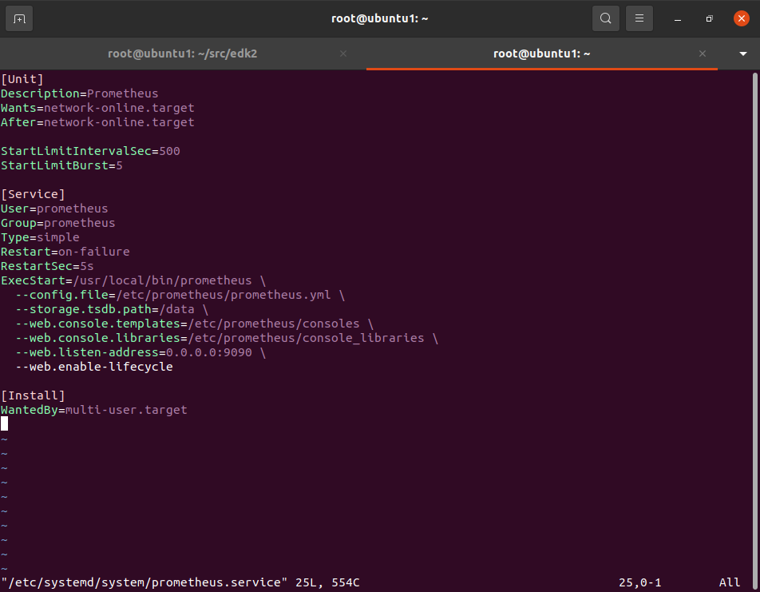

And save the file.

**Step 12:-** enable prometheus

$ sudo systemctl enable prometheus



**Step 13 :-** start the Prometheus

$ sudo systemctl start prometheus

**Step 14:-** check the status of Prometheus

$ sudo systemctl status prometheus

**Step 15:-** to access via browser, use the ip address of the server with the port no. 9090

<http://192.168.122.47:9090>

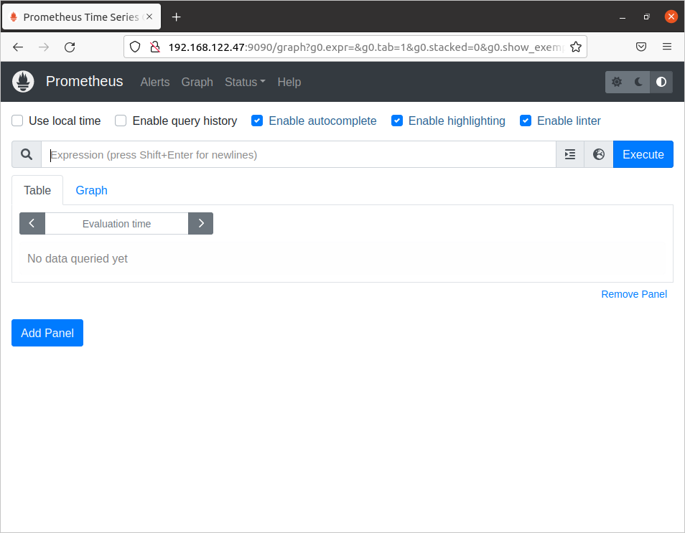

**Step 16 :-** to check the targets click on status then targets

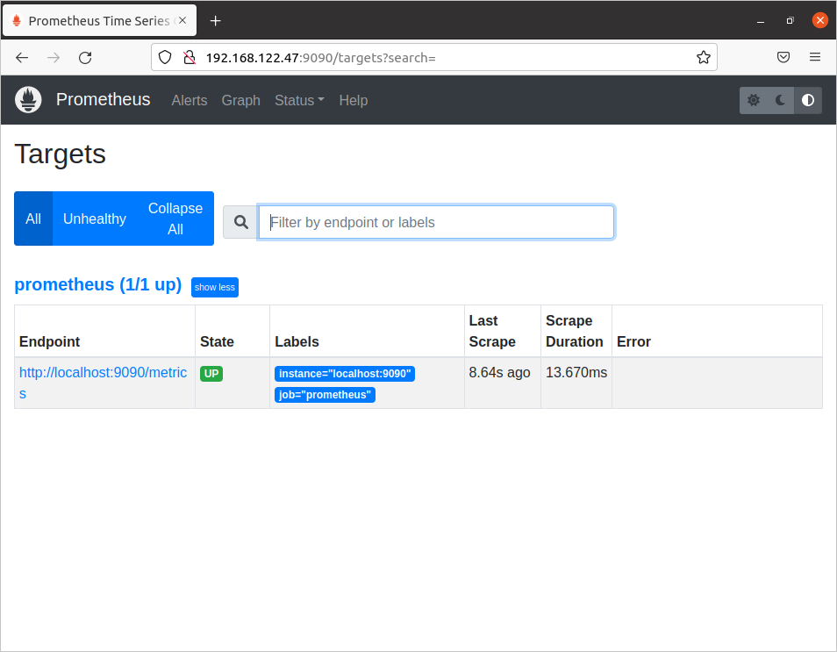

**Prometheus setup is completed**

**Setup Grafana:-**

I follow some steps for setup grafana in ubuntu which is given below:-

**Step 1:-** install all dependencies of grafana

$ sudo apt-get install -y apt-transport-https software-properties-common

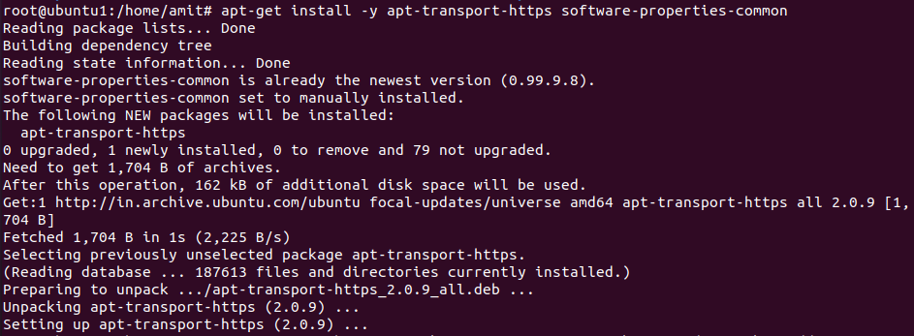

**Step 2:-** add GPG key in grafana

$ sudo wget -q -O - https://packages.grafana.com/gpg.key | sudo apt-key add -



**Step 3:-** add a repository for stable releases.

echo "deb https://packages.grafana.com/oss/deb stable main" | sudo tee -a /etc/apt/sources.list.d/grafana.list



**Step 4:-** update ubuntu

$ sudo apt-get update

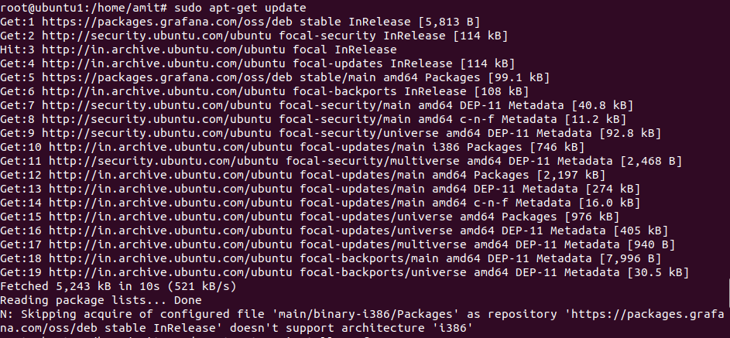

**Step 5:-** install grafana

$ sudo apt-get install -y

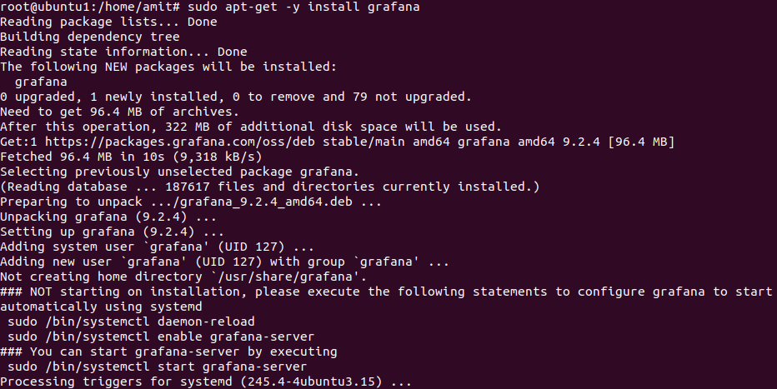

**Step 6:-** enable the grafana

$ sudo sudo systemctl enable grafana-server

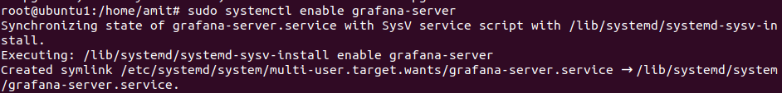

**Step 7:-** start the grafana

$ sudo systemctl start grafana-server

**Step 8:-** check the status of grafana

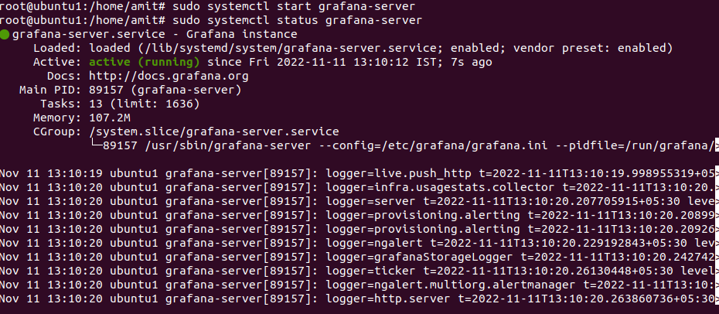

**Step 9:-** go to the browser and search **localhost:3000**

Then, enter the username and password are **admin**

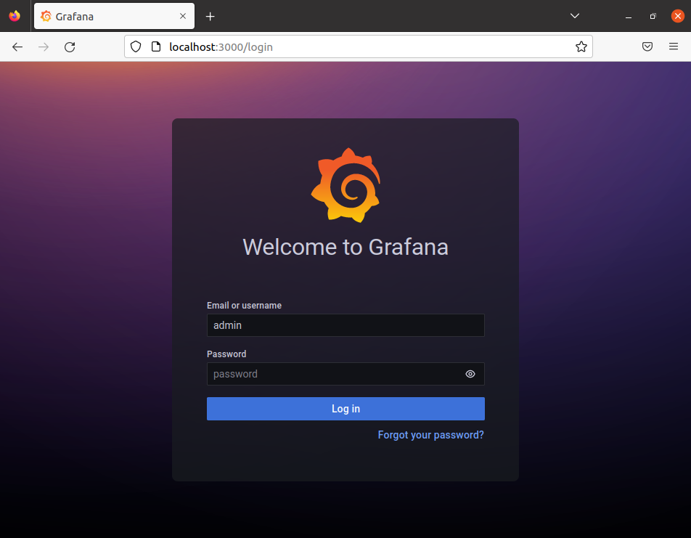

**Step 10:-** set new password for login and you go to the dashboard of grafana



**Step 11:-** go to the terminal and Create a new **datasources.yaml** file.

$ sudo vim /etc/grafana/provisioning/datasources/datasources.yaml

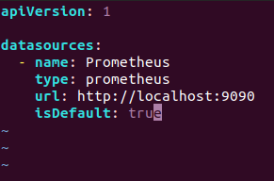

**Step 12:-** Restart Grafana to reload the config

$ sudo systemctl restart grafana-server

**Step 13:-** Go back to Grafana and refresh the page. There will be a page of the Prometheus data source.

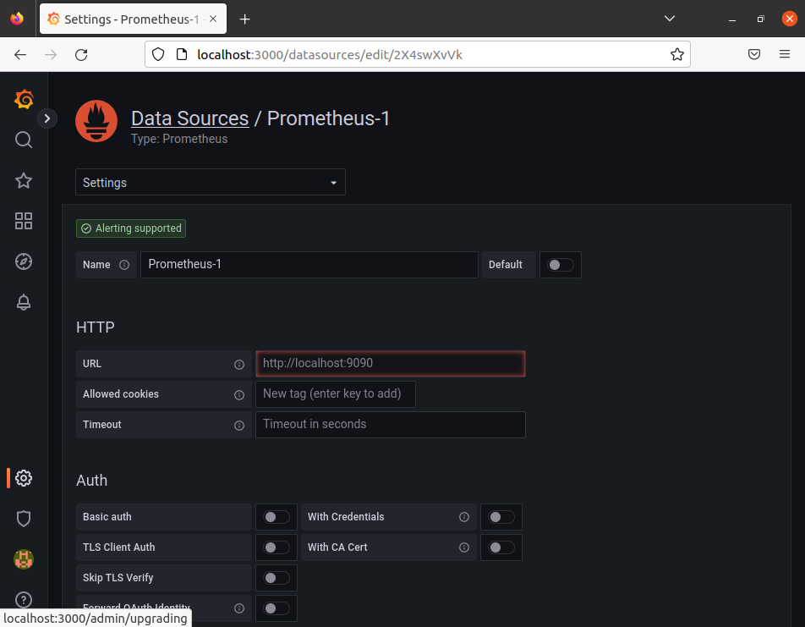

**Grafana setup is completed.**